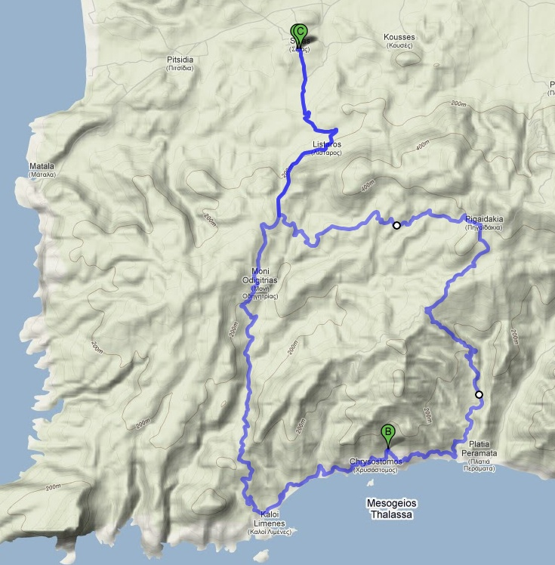
Tour 1 ca. 38 km, ca. 750 HM
Sivas - Moni Odigitrias – Kaloi Limenes – Chrysostomos – Platia Peramate – Pigaidakia – Sivas

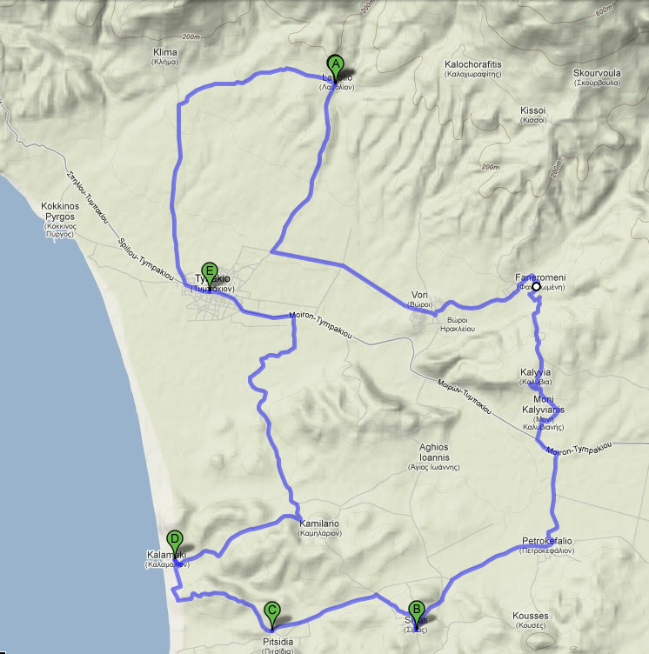
Tour 2 ca. 40 km ca. 150 HM
Sivas – Petrokefalia – Moni Kalyvianis – Kalyvia – Faneromeni – Vori – Lagolio – Tymbaki - Kamilario(Villa) – Kalamaki – Pitsidia - Sivas

